M.C.Ptk e – NEWS

*MUNICIPAL CORPORATION PATHANKOT*

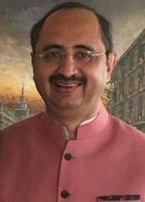 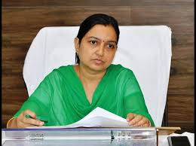

**Sh. Anil Vasudeva July 2017 Smt. Neelima**

**(Mayor) IAS(Commissioner)**

Municipal Corporation Pathankot is releasing its e-newsletter for July 2017, which has been named as MCPtk e-News. E-News will bring awareness among citizens about various works done and being taken up by MC Pathankot. The newsletter will act like a common platform for public and MC Pathankot, with this effort we will be closer to the citizens by focusing on development activities of MC Pathankot. We congratulate the whole team for this noble concept and also wish continuity of publication of this newsletter.

**ATAL MISSION FOR REJUVENATION AND URBAN TRANSFORMATION (AMRUT)**

AMRUT Mission was launched by ministry of Urban Development Government of India on 25 June, 2015.

**Objectives:-**

Providing basic services (e.g Water supply, Sewerage, Parks and Urban transportation) to households and build amenities in cities which will improve the quality of life for all, especially the poor and the disadvantaged is a national priority of this scheme.

**Government of Punjab in the department of Local Government has taken various initiatives to achieve these reforms.**

* Preparation of GIS based master plans.
* Digital India initiatives for laying cables for digital/ web networking.
* Transfer of funds under 14th Finance Commission to ULBs.
* Solar roof top panels policy and Net Metering, for more details click to the website of PEDA : solarpunjab.com
* Rain Water Harvesting (RWH) : Already there is a provision in Punjab Municipal Building Bye Laws for RWH, for more details please visit website of Department of Local Government Punjab : lgpunjab.gov.in
* To achieve full potential of advertisement revenue by making policy for destination specific potential having dynamic pricing module, Advertisement policy was notified by the Government which is available online.
* Incentives to Green buildings : A policy was notified by the Government giving incentives to green buildings, for more details visit at the website of MC Pathankot : [www.mcpathankot.gov.in](http://www.mcpathankot.gov.in)
* Cadre linked training: The Government has initiated various cadre linked training programs under AMRUT and other schemes.
* Complete the credit ratings of the ULBs : Government has engaged a company called M/s Brickwork Ratings India Pvt. Ltd.
* SLIP and SAAP have been prepared and action plan has been also prepared for water supply, sewerage and action plan for parks and open spaces in under process.

**SWACHH BHARAT MISSION (SBM)**

The Swachh Bharat Mission (SBM) emanates from the vision of the government articulated in the address of the President of India in his address to the joint session of Parliament on 9th June 2014 :-

" We must not tolerate the indignity of homes without toilets and public places littered with garbage, for ensuring hygiene, waste management and sanitation across the nation, a " Swachh Bharat Mission" will be launched. This will be tribute to Mahatma Gandhi on his 150th birthday anniversary to be celebrated in the year 2019."

SBM is being implemented by the ministry of Urban Development (M/o UD) and by the ministry of Drinking water and sanitation (M/o DWS) for urban and rural areas respectively. These guidelines are for the implementation of Swachh Bharat Mission (Urban).

**Mission Objectives:-**

* Elimination of open defecation.
* Eradication of manual scavenging.
* Modern and scientific municipal solid waste management.
* To effect behavioral change regarding healthy sanitation practices.
* Generate awareness about sanitation and its linkage with public health.
* Capacity Augmentation for ULBs.
* To create an enabling environment for private sector participation in Capex (Capital expenditure) and Opex (Operation and maintenance).

**Mission Components:-**

* Household toilets, including conversion of insanitary latrines into pour flush latrines.
* Community toilets.
* Public toilets.
* Solid waste management.
* IEC and public awareness.
* Capacity building and Administration and office expenses (A & OE).

**Municipal Corporation Pathankot**

**Swachh Bharat Mission**

* Efforts done by municipal corporation pathankot to make city clean under Swachh Bharat Mission.

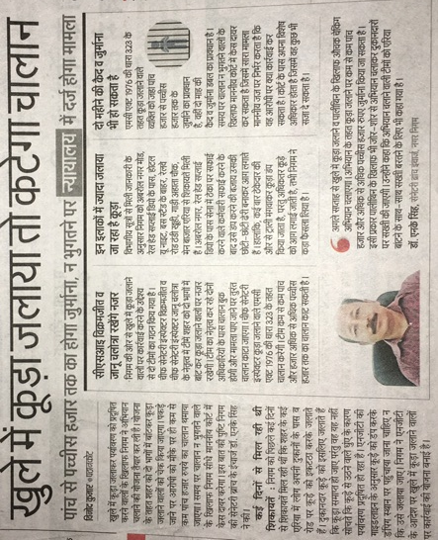

**Municipal Corporation Pathankot**

**Property Tax Payments**

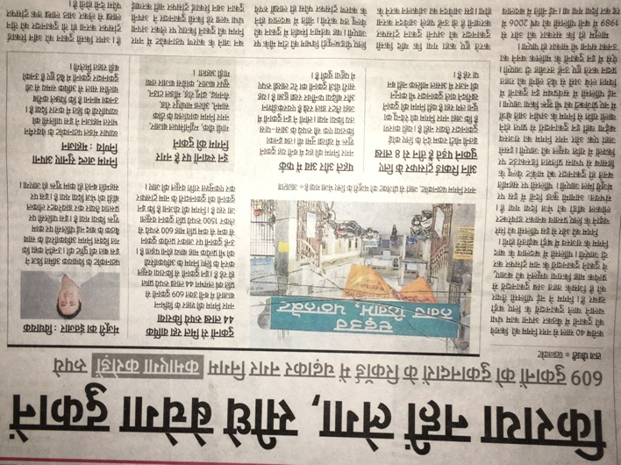

**Municipal Corporation Pathankot**

**Water Supply & Sewer Charges**

* Action taken by Municipal Corporation against illegal connections of water supply & sewer in the city

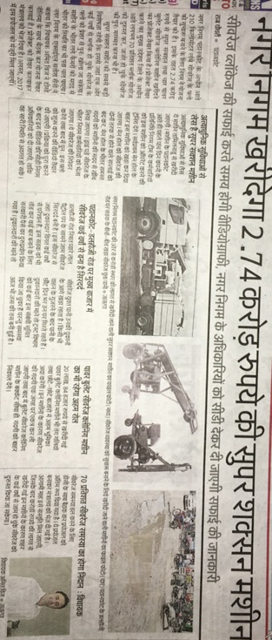

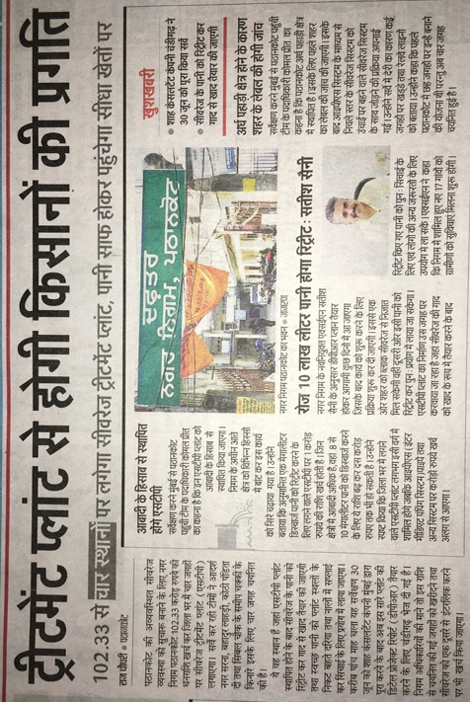

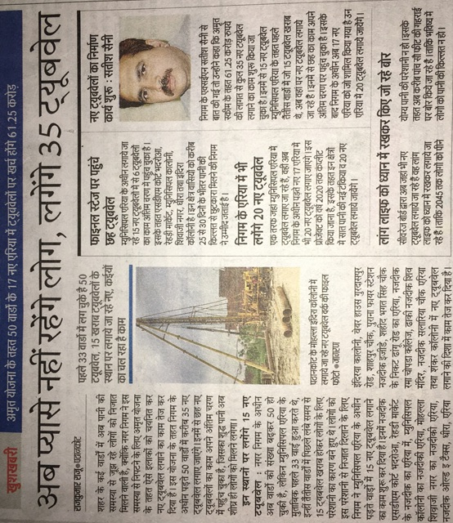

**Municipal Corporation Pathankot**

**Building Branch**

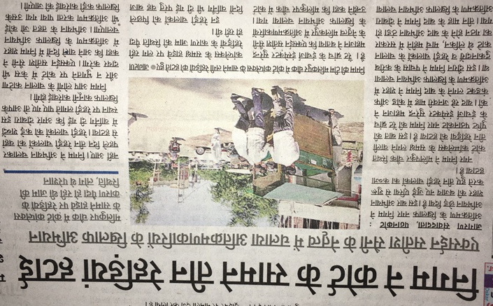

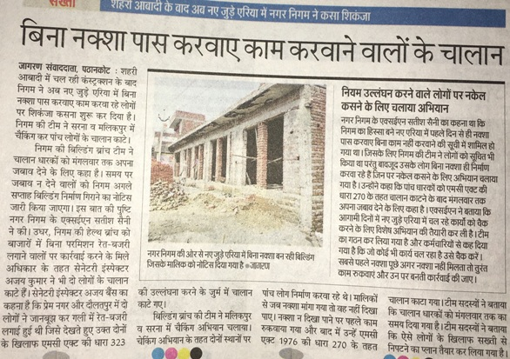

***Contact us:-***

***Municipal Corporation Pathankot***

***Opp. Shimla Park***

***Main Bazar, Pathankot***

***e-mail :-*** [***eomcptk@yahoo.co.in***](mailto:eomcptk@yahoo.co.in)

***Tel.:- 01862220230***